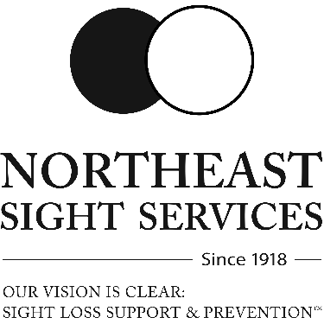
Call 570-693-3555 x240 to RSVP Please leave a message and indicate if you will need transportation and if you will be bringing a guide. Transportation provided to residents of Luzerne County.
AUGUST 2026 CLIENT EVENTS

- Thursday, Aug. 6th – Out&About- Sip for Sight!
5:30 PM – 7:00 PM RSVP by Mon. Aug. 3rd
Location- Susquehanna Brewing Company, 635 S. Main St. Pittston
Come out and join the fun of Northeast Sight’s Sip for Sight community fundraiser! See if you have what it takes to correctly identify different flavors of SBC beer or Old Farmer’s Iced Tea while blind folded.
- Monday, August 10th – Supper and Support
5:00 PM – 6:30 PM RSVP by Mon. Aug. 3rd
Menu: Tacos
- Tuesday, August 18th – Lunch & Learn – Low-Cost Glasses
and Free Eye Exams
11:30 AM – 1:30 PM RSVP by Tue. Aug. 11th
Menu: Egg Salad Hoagies
Are you, or someone that you know, in need of affordable glasses? Do you need an eye exam but lack insurance? We have programs that can help! Come learn who qualifies and what the process entails.
- Thursday, August 20th – BINGO
5:00 PM – 7:00 PM RSVP by Thur. Aug. 13th
Menu: Chicken cutlets, roasted reds, chef medley veggies
- Tuesday, August 25th – Books and Baking
1:30 PM – 3:00 PM RSVP by Tue. Aug. 18th
Making: 5-Minute Fruit Mousse
Reading: Project Hail Mary By: Andy Weir DB: 103718

